1. Add 8 to the following AVL tree

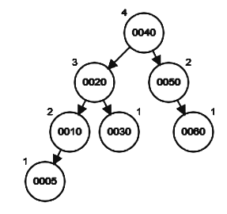

1. Add 70 to the following AVL tree



1. Add 39 to the following AVL tree

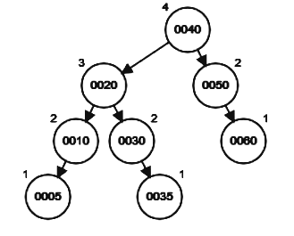



1. Add 44 to the following AVL tree

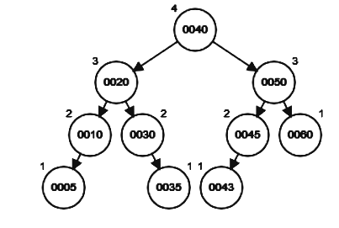

1. Add 40 to the following AVL tree



1. Remove 60 from the following AVL tree

